

Department of Computer Science and Engineering

Software Requirements Specifications (SRS)

**NextGenTech**

|  |  |
| --- | --- |
| Submitted By :  **Name : Ashraf Uddin Shuvo**  ID : 0432220005101018  **Name : Mobarok Hossain Zobaer**  ID : 0432220005101029  **Name : Sadia Akter Tuly**  ID : 0432220005101030  **Name : Md. Tamim Iqbal**  ID : 0432220005101023 | Submitted To :  Md. Shafaet Hossain  Associate professor,  Department of CSE, UITS |

Submission Date : 11 March, 2025

**Electronics E-Commerce Website with AI Recommendations (NextGenTech)**

Table of Contents

Table of Contents for a SRS Document

**1. Introduction**

1.1 Purpose

1.2 Document Conventions

1.3 Intended Audience and Reading Suggestions

1.4 Project Scope

1.5 References

**2. Overall Description**

2.1 Product Perspective

2.2 Product Features

2.3 User Classes and Characteristics

2.4 Operating Environment

2.5 Design and Implementation Constraints

2.6 Assumptions and Dependencies

**3. System Features**

3.1 Functional Requirements

**4. External Interface Requirements**

4.1 User Interfaces

4.2 Hardware Interfaces

4.3 Software Interfaces

4.4 Communications Interfaces

**5. Nonfunctional Requirements**

5.1 Performance Requirements

5.2 Safety Requirements

5.3 Security Requirements

5.4 Software Quality Attributes

**1. Introduction**

**1.1 Purpose**

The purpose of this document is to define the software requirements for an Electronics E-Commerce website that integrates AI-based product recommendations and multiple online payment options. The system aims to provide a seamless, secure, and user-friendly shopping experience.

**1.2 Document Conventions**

This document follows IEEE standards for SRS documentation and includes functional and non-functional requirements.

|  |  |
| --- | --- |
| DB | Database |
| DDB | Distributed Database |
| ER | Entity Relationship |

**1.3 Intended Audience and Reading Suggestions**

This document is intended for Developers, Project Managers, Quality Assurance Team, Stakeholders, and End Users. Developers will use it to understand system requirements and implementation details, while Project Managers will oversee the development process. The Quality Assurance Team will refer to it for testing and validation, Stakeholders will review it to ensure the project aligns with business objectives, and End Users can understand the system’s capabilities and functionalities.

**1.4 Project Scope**

The website will offer a platform for users to browse, purchase, and get recommendations for electronics products. AI-driven recommendations will enhance user experience, and secure payment gateways will ensure smooth transactions. The website will have a responsive design to support multiple devices.

**1.5 References**

<https://www.startech.com.bd/>

**2. Overall Description**

**2.1 Product Perspective**

This e-commerce website is an independent platform that connects users with a variety of electronic products. It integrates AI technology for personalized recommendations and secure payment methods for transactions.

**2.2 Product Features**

* User Registration and Login
* Product Browsing & Search
* AI-Based Product Recommendations
* Shopping Cart & Wishlist
* Multiple Payment Options
* Order Tracking System
* Responsive Design for Mobile and Desktop

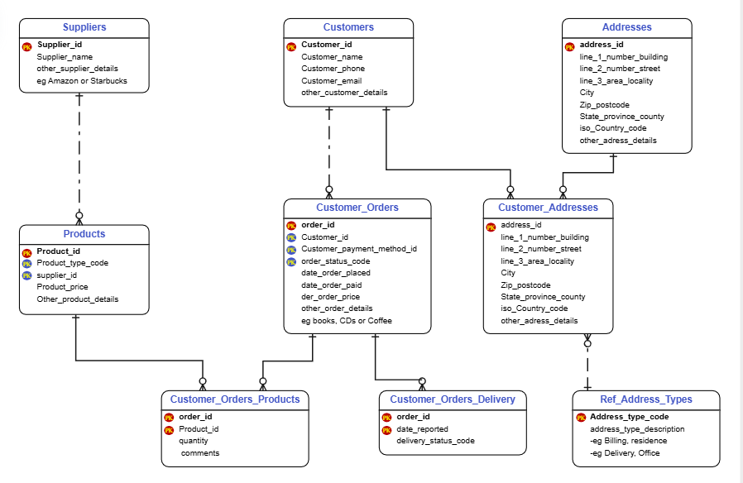

**2.3 User Classes and Characteristics**

* **Customers:** Users looking to purchase electronics.
* **Admin:** Manages product listings, orders, and analytics.
* **Sellers (Optional):** Vendors listing their products for sale.

**2.4 Operating Environment**

* Web-Based Application (Compatible with Chrome, Firefox, Edge, Safari)
* Hosting on Cloud Servers (AWS)
* Backend: Node.js
* Frontend: React.js
* Database: MySQL or MongoDB

**2.5 Design and Implementation Constraints**

* Secure handling of user payment details
* Fast and optimized recommendation system
* Scalability for future expansion

**2.6 Assumptions and Dependencies**

* Users will have internet access
* Payment gateway APIs are functional and updated regularly
* AI recommendation system will require continuous data updates

**3. System Features**

**3.1 Functional Requirements**

* Users can register, log in, and manage their profiles
* AI-based product recommendations based on browsing history
* Secure integration of bKash, Nagad, and card payment systems
* Users can track orders and receive notifications
* Responsive design ensuring mobile-friendliness

**4. External Interface Requirements**

**4.1 User Interfaces**

* Home Page with Featured Products
* Product Detail Page with AI Recommendations
* Shopping Cart and Checkout Page
* User Dashboard for Order Management

**4.2 Hardware Interfaces**

* Hosted on cloud servers with high-speed processing

**4.3 Software Interfaces**

* Payment Gateway APIs
* AI Recommendation Engine

|  |  |
| --- | --- |
| **Software used** | **Description** |
| Operating system | We have chosen Windows operating system for its best support and user-friendliness. |
| Database | To save the customer records, seller records we have chosen SQL database. |
| NodeJs, Express Js | To implement the project we have chosen NodeJs , Express Js for backend technology. |
| HTML, CSS, JS, React | To implement the project we have chosen those language for its more interactive support. |

**4.4 Communication Interfaces**

* Email Notifications for Order Updates

**5. Nonfunctional Requirements**

**5.1 Performance Requirements**

* Website should load within 3 seconds
* AI recommendations should generate results in under 1 second

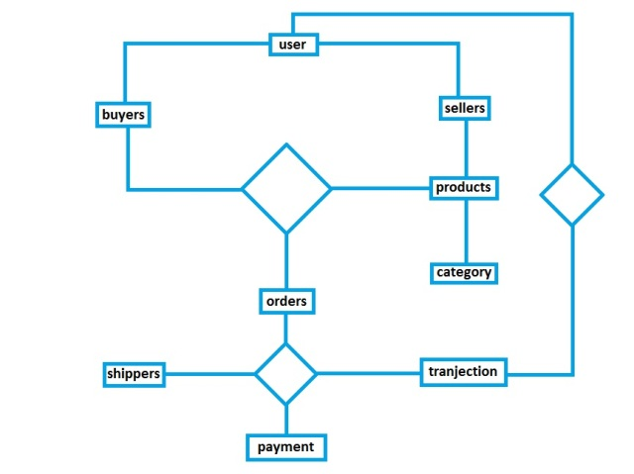

**5.2 Safety Requirements**

* Secure payment transactions with encryption
* User data privacy compliance (GDPR, local regulations)
* Normalization

**5.3 Security Requirements**

* SSL/TLS encryption for data transmission
* Secure authentication (FireBase Authentication, JWT)

**5.4 Software Quality Attributes**

* Usability: Intuitive UI/UX
* Maintainability: Modular codebase for easy updates
* Scalability: Support for high traffic loads

This document outlines the fundamental requirements for the Electronics E-Commerce website with AI-driven recommendations and multiple payment options. Additional refinements can be made based on development progress and stakeholder feedback.